**Train a custom image model**

To start training a model with your COCO file, go to the Custom models tab and select Add a new model. Enter a name for the model and select Image classification or Object detection as the model type.

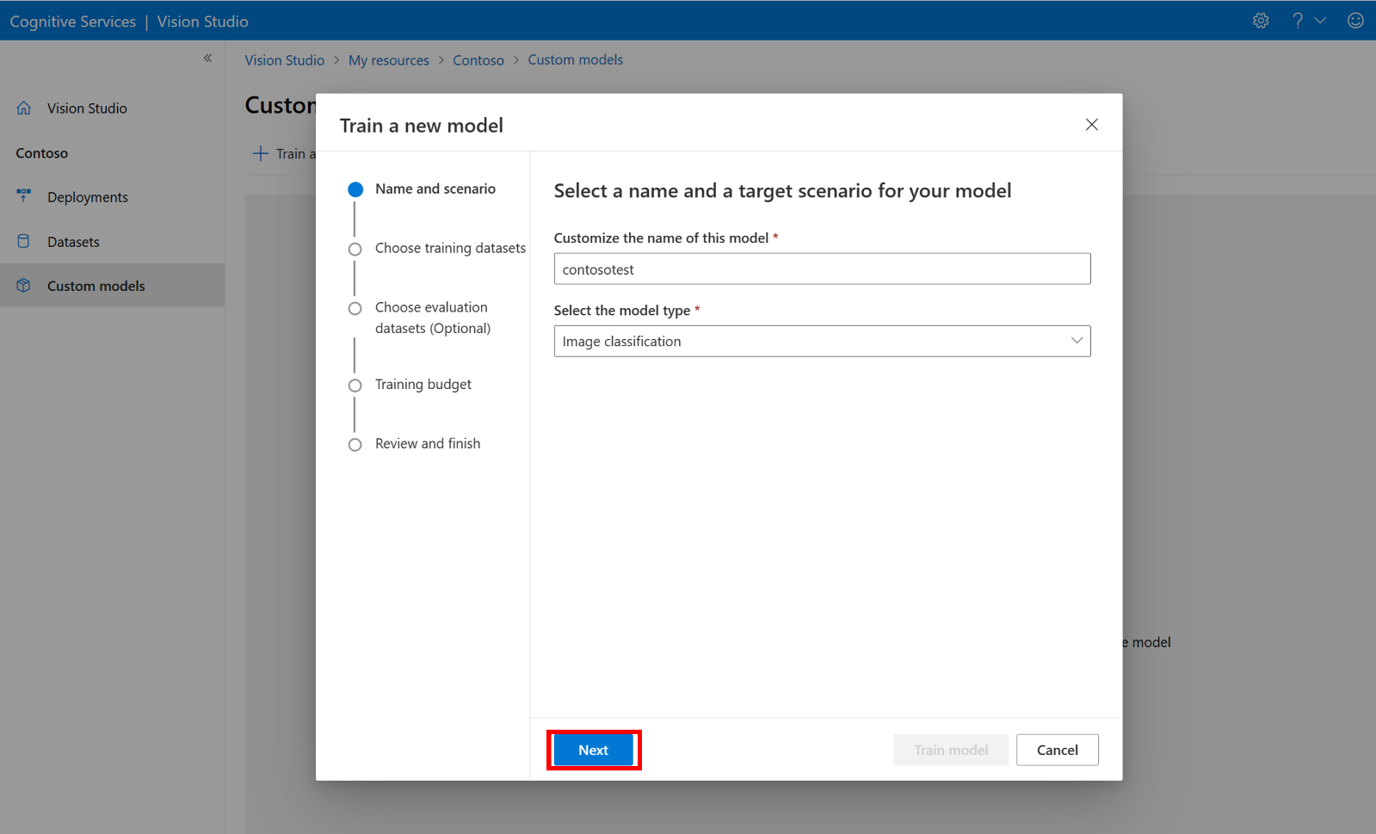

Select your dataset, which is now associated with the COCO file containing the labeling information.

Then select a time budget and train the model. For small examples, you can use a 1 hour budget.

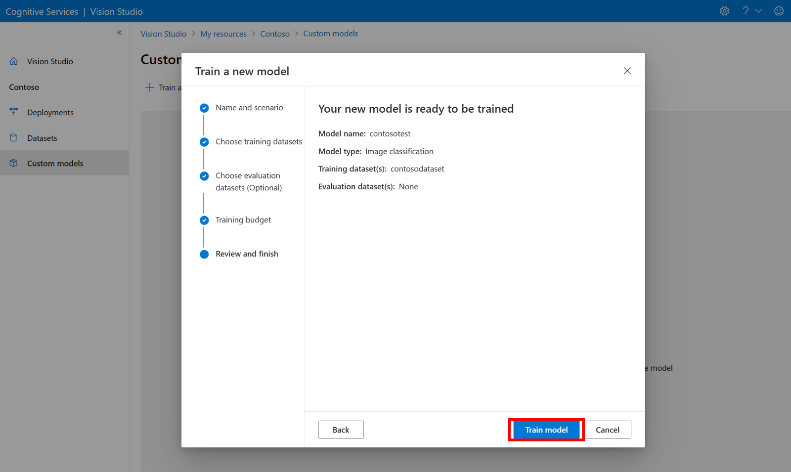

It might take some time for the training to complete. Image Analysis 4.0 models can be accurate with only a small set of training data, but they take longer to train than previous models.

